**Electric Charging station Finder App “GreenHouse”**

**Rationale:**

Dwindling stocks of raw materials, environmental issues around global warming and rapid urbanization in the developing world are among the challenges that cripples over sustainability and the future of the planet. In today’s world, where Government agencies and organizations have framed more stringent standards for fuel consumption, emissions, global warming and constraints on energy resources, Battery-powered electric vehicles (EV) were one of the solutions proposed to tackle the energy crisis and global warming. Certainly, EVs offer a cleaner alternative to internal combustion engines and may represent the future of "green" automobiles. It is a well-known fact that Electricity is less expensive than gasoline and EVs are more efficient than gasoline vehicles. On a national average, it costs less than half as much to travel the same distance in an EV than in a conventional vehicle. EVs can also reduce the emissions that contribute to climate change and smog, thus improving public health and reducing ecological damage. Again, EVs can help the world have a greater diversity of fuel choices available for transportation . Unsurprisingly, the development of electric vehicles (EV) has attracted more and more attention by automakers, governments, and mass population. Since, Plug-in electric vehicles (also known as electric cars or EVs) can save money, with much lower fuel costs on average than conventional gasoline vehicles, this trend of attraction will eventually grow to everywhere irrespective of developing countries (Bangladesh, Cambodia, Myanmar, Ethiopia, Tanzania), emerging countries (China, India, Brazil, South Africa), and developed countries (Japan, Canada, USA, Germany, Britain, etc.). Nevertheless, various jurisdictions throughout the world, compelled by the energy crisis and global warming, started to formulate and enact law to encourage on the use of zero emission vehicles which will also act as a catalyst for generating attraction towards EVs. According to IHS Markit (Oil research and energy mobility research), currently, there are more than 2.8 million electric cars on the road, and the electric vehicles could reach 36 million by 2025. IHS forecasts that Electric vehicles are expected to be 30% of new car sales by 2040, up from 1% today.

From the above discussion, it is well understood that the necessity of Electric charging station will accelerate as the demand for Electric Vehicles increase. Obviously, some analysts estimate that the world will sooner or later need private and public sources to provide hundreds of thousands of charging stations well beyond the current available no of charging stations. Considering the importance of electric car and charging stations, we have planned to introduce a Web Application with apps name “GreenHouse”.

**Usability of Electric Charging Station:**

Electric-drive vehicles use electricity as their primary fuel or to improve the efficiency of conventional vehicle designs. An electric vehicle charging station, also called EV charging station, electric re-charging point, charging point, charge point and EVSE (electric vehicle supply equipment), is an element in an infrastructure that supplies electric energy for the re-charging of electric vehicles, such as plug-in electric vehicles, including electric cars, neighborhood electric vehicles and plug-in hybrids.

As plug-in hybrid electric vehicles and battery electric vehicle ownership are expanding, there is a growing need for widely distributed publicly accessible charging stations (some of which support faster charging at higher voltages and currents than are available from residential EVSEs). Many charging stations are on-street facilities provided by electric utility companies or located at retail shopping centers and operated by many private companies.

**Description of the Application:**

This app is a web-based service that will provide consumers (electric car drivers) with nearby public & privately available charging stations exact location where one can reserve an available charging point in a station and charge the vehicle by registering through internet. In other words, finally this app will connect EV drivers to underutilized charging points through a peer-to-peer charging network Also the charging station owners can expand and illustrate his business globally. Once the initial rollout of the web-service is complete, we will develop a mobile app.

**Host & User:**

If any homeowner is interested to earn money by sharing unutilized charging points, they can register as a host. On the other hand, if any consumer (electric car driver) is looking for an extra-charging while driving a trip to a far-off destination or regular charger to plug into near home, they will be able to register as a user. Users can search for nearby hosts and see when charging points are available for them to charge. And then reserve by requesting an open calendar slot from the available charging points which hosts allocated. This app will help the following:

- Find a charging station

- Reserve it for a guaranteed space.

- Plug in car and charge

- Payment and Transaction

- Rate the App

The GreenHouse app will connect EV charging station owners with EV consumers by providing a platform that connects privately owned infrastructure to expand charging options for EV drivers. This includes a reservation system which gives drivers assurance that the charger will be held for them during a fixed window. This is a unique facility and a key differentiator, as it is very common to arrive at a charger only to find that someone else is there charging. Charging units can be installed in residential, fleet, workplace, and public settings.

**Geographical Consideration:**

At the beginning, the application will cover Toronto area and later the team will scale the solution to a broader user base to validate the new end-to-end solution before developing platform-specific apps and expanding the network to the rest of Ontario and beyond.

How this app will work?

**For Electric Car drivers:**

➢ Firstly, download and install the app on your mobile

➢ It will show two options driver and station owner.

➢ Select driver, click Sign Up button then register for first time using name, mobile no, username, password and vehicle number also upload an image.

➢ After that click Login button put username, password .

➢ Click Search button, then you can see all nearest electric charging station from you with exact location, distance, arriving time and available charging slot of each charging station using different colors also see the rate, how much time need for charging and price also.

➢ Then you can choose one slot from among charging station

➢ When you booked one slot then its color will be changed

➢ There has duration of booking time, after booking any of the slots if you cannot reach within the time the booked will canceled.

➢ After arrived you can plug in your car into the electric charging station

➢ Every charging station will have a sensor, it can be sensed when a car plug in and plug out.

➢ When a car plug in into charging station, there has a timer and counter which can figure out how many times be needed for charging a car and how many car be charged in a day from this charging slot.

➢ According to timer info sensor will send a message with billing information to station owner and also car driver.

➢ Then car driver can give payment for charging his car.

➢ After every booking successfully completed there is a rating system which select you a best client of this app and has an option to reward.

➢ Sometimes this app provides some commission according to customer and Electric charging station ratings.

➢ Finally the app will provide you two options that is satisfied yes or no. you can choose one or close the app.

➢ For second time login, only open the app and click search button directly.

**For Electric Charging Station owner:**

➢ Firstly, to provide electric charging station visual in this app, it has to be register into this app.

➢ For registering into this app they have nothing to pay any bucks.

➢ For register into this app, download the app and install it in your mobile also can register using this website named [www.chargingvehicles.com](http://www.chargingvehicles.com).

➢ It will show two options driver and station owner.

➢ Select station owner, click Sign Up button for registering, insert name, mobile, state, city, zip code, username, password, number of slots and upload a picture of your stations.

➢ After that click Login button put username, password.

➢ After registering you can see a dashboard, in dashboard you can do following:

* Vehicle and rate setting (Which vehicle will be charged from this charging station)
* General setting (Company profile)
* How many vehicle are charging in station and how many booked
* All transaction information
* You can set discount
* Rating this app

➢ You can book any vehicles in your charging station directly. When you booked some slots the color of slots will be changed no one can booked this slot while the booked is completed or canceled.

➢ You can get payment by online transaction or cash.

➢ After completing the task please rate the app.

More options and features will be developed day by day.

**Technical description**:

For developing this application, it has to be used different types of API (Application Programming Interface), devices, Framework, platform.

**API (Application Programming Interface):**

* Google Map API
* GIS
* REST API
* API Gateway
* Other related API’s which will need to complete this application.

**Devices:**

* Sensors
* Modules
* Timer
* Counter
* PLC (Programmable Logic Controller)
* Micro-Controller
* Other related devices

**Framework, Programming and database design:**

* Java programming
* Spring Boot
* Swagger
* Apache camel for stream cashing
* Spring Data JPA
* Spring security
* Auth2 Authentication for API security
* React JS
* React Bootstrap
* Redux, Saga, Selector, Reducer, Jqx grid
* Faker & js pdf for reporting, I report
* My SQL Server etc

**Platforms:**

* Web Platform
* Android Platform
* IOS Platform etc.
* Windows platform
* Linux
* Any kinds of operating system
* Any kinds of smart devices

**Other Facilities:**

* Responsive
* Dynamic
* Platform independent
* Efficient
* Multi-lingual
* Updateable
* Secure
* Easy to access
* Time consuming
* Interactive
* Environment friendly

**Uniqueness of this project:**

1. Helping Government to develop economic development
2. Removing environmental effect from greenhouse effect
3. Providing business to electric charging owner
4. Removing Transport pollution
5. Marketing of any kinds of vehicle business
6. Providing exact information to car owners for charging his car emergency
7. Removing global warmi

**How the API will work:**

Account Service for Station Owner

REST API

­­­­­­

REST API

API Gateway

Search Service

REST API

REST API

REST API

REST API

REST API

REST API

Payment Service

Massaging Service

Charging Service

Sensor Service from Charging Station

Booking Service

Account Service for Car Driver

**DFD ( Data Flow Diagram) for Car Driver:**

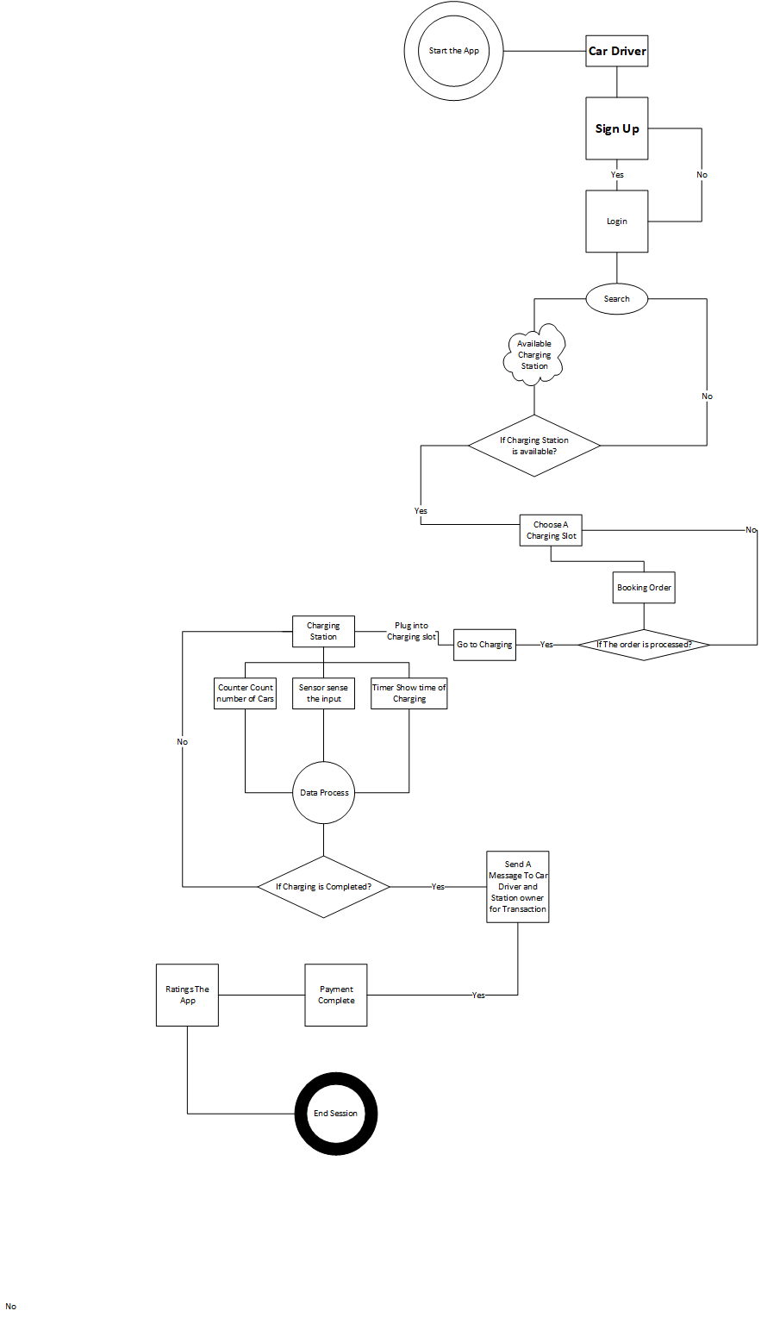

**DFD (Data Flow Diagram) For Station Owner:**

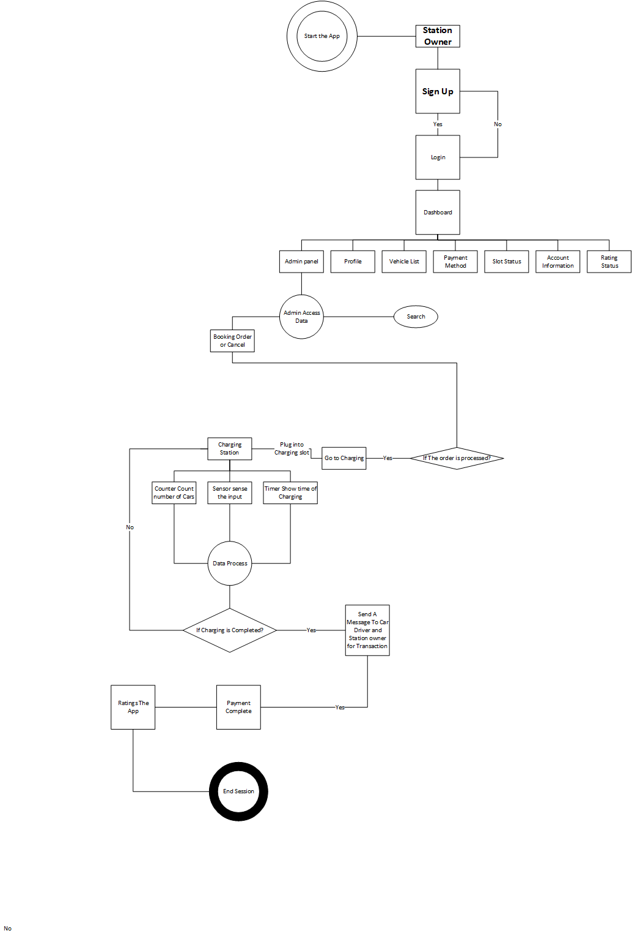

**ER Diagram of GREENHOUSE:**

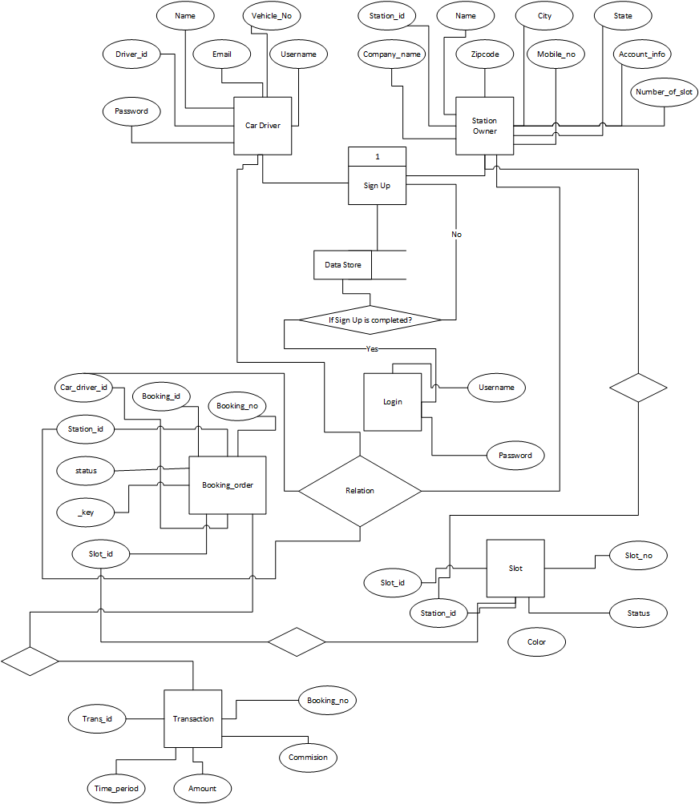

**Benefits:**

**Conclusion:**